Images to Audio Story Generator by Using Python

¹ SATISH VARADA,²VAKADA MAHENDRA REDDY
¹Assistant Professor, ²2MCA Final Semester, Master of Computer Applications, Sanketika Vidya Parishad Engineering College, Vishakhapatnam, Andhra Pradesh, India

Abstract
The Image to Audio Story Generator is a Python-based AI application developed using Streamlit that converts uploaded images into engaging audio stories. The project integrates computer vision, natural language processing, and text-to-speech technologies to create an automated storytelling experience. The system uses the Salesforce BLIP image captioning model to analyze images and generate descriptive text. The extracted image description is then processed using the OpenAI GPT-3.5 Turbo model to generate creative and context-aware short stories. Finally, the generated story is converted into audio format using the Google Text-to-Speech (gTTS) library, allowing users to listen to the AI-generated narrative. The application is built entirely in Python and provides a simple and user-friendly interface through Streamlit for uploading images, viewing generated stories, and playing audio output. This project demonstrates the practical integration of AI models, deep learning, and multimedia processing to enhance storytelling, creativity, and accessibility.
IndexTerms: Image Captioning; Audio Story Generation, Artificial Intelligence (AI), Natural Language Processing (NLP), Text-to-Speech (TTS), Generative AI.

- INTRODUCTION
The rapid growth of Artificial Intelligence (AI), Deep Learning, Computer Vision, Natural Language Processing (NLP), and Speech Synthesis technologies has revolutionized the way computers understand and communicate information.[23] These advancements have enabled intelligent systems to interpret visual data, generate meaningful text, and produce human-like speech. Image captioning is a significant application of computer vision that automatically generates descriptive captions for images by analyzing their visual content. Natural Language Processing further enhances this process by creating coherent and contextually relevant narratives. Text-to-Speech (TTS) technology converts the generated text into spoken audio, improving accessibility and user engagement. The proposed project, [13]"AI-Powered Multilingual Image-to-Audio Story Generation System Using Python," integrates image captioning, story generation, language translation, and speech synthesis into a single platform. The system transforms uploaded images into descriptive audio stories in multiple languages, making visual content more interactive and accessible. This solution has potential applications in education, digital storytelling, entertainment, and assistive technologies for visually impaired users. The project demonstrates the effective integration of modern AI technologies to create an intelligent multimedia storytelling system.[6]

  - Existing System
Existing image-based storytelling systems mainly focus on individual tasks such as image captioning, text generation, translation, or text-to-speech conversion rather than providing a complete integrated solution.[22]Traditional image captioning systems generate only short descriptions of images and cannot create meaningful stories with proper context and creativity. [1]Many storytelling applications require manual prompts or keywords from users, reducing automation and convenience. Similarly, text-to-speech systems only convert existing text into audio and cannot automatically generate content from images. [05]Most available systems also lack multilingual support, limiting accessibility for users from diverse linguistic backgrounds. In addition, they often fail to provide effective support for visually impaired users who depend on audio descriptions. Older machine learning and rule-based approaches produce repetitive and less engaging outputs, affecting the quality of generated content.
[12]The separate implementation of image processing, story generation, translation, and speech synthesis increases system complexity and reduces efficiency. Therefore, a unified AI-based solution is needed to automatically transform images into multilingual audio stories, providing a more intelligent, accessible, and user-friendly experience.[14]

1.1.1 Challenges:
- Accurate Image Caption Generation
Generating meaningful captions from complex images was challenging because the BLIP model sometimes failed to identify all objects, actions, or relationships correctly.
- Understanding Image Context
Images containing multiple objects, emotions, or activities were difficult to interpret accurately, affecting the quality of the generated captions and stories.
- Integration of Multiple AI Technologies
Combining BLIP Image Captioning, Story Generation, Translation, and gTTS into a single workflow required careful coordination between different libraries and modules.
- Story Generation Quality
Converting short image captions into meaningful, creative, and context-aware stories while maintaining grammatical correctness was a major challenge.
1.2 Proposed system:
The proposed system is an AI-Powered Multilingual Image-to-Audio Story Generation System that automatically converts images into meaningful stories and audio narrations. The system provides a Streamlit-based user interface through which users can upload images easily. [3]The uploaded image is analyzed using the BLIP image captioning model, which generates an accurate textual description of the image content. [21]The generated caption is then processed by the story generation module to create a coherent and engaging narrative. To improve accessibility, the generated story can be translated into multiple languages such as English, Telugu, Hindi, Tamil, and Malayalam. The translated story is further converted into speech using Google Text-to-Speech (gTTS) technology. The system integrates image captioning, story generation, translation, and speech synthesis into a single platform. Both the textual story and audio narration are displayed to the user through the application interface. This automated workflow reduces manual effort and enhances user experience. The proposed system is particularly useful for education, digital storytelling, multimedia applications, and accessibility support for visually impaired users.[11]

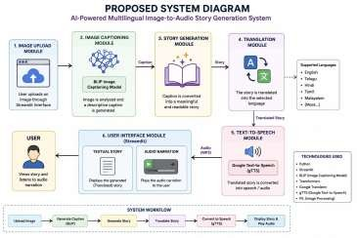
Fig: 1 Proposed Diagram

1.2.1 Advantages:
- Complete Automation
Automatically converts images into stories and audio narrations without requiring manual text input.[10] ⚫ Accurate Image Understanding
Uses the BLIP Image Captioning Model to analyze images and generate meaningful captions.
- Intelligent Story Generation
Transforms simple image descriptions into engaging and readable stories using AI techniques.
- Multilingual Support
Supports multiple languages such as English, Telugu, Hindi, Tamil, and Malayalam, making the system accessible to diverse users.
- Audio Narration Feature
Converts generated stories into speech using Google Text-to-Speech (gTTS), enabling hands-free content consumption.
2.1 Architecture:
The architecture of the proposed system consists of six major modules that work together to process images and generate audio stories.
Components of Architecture
- User Interface (Streamlit)
- Image Upload Module
- BLIP Image Captioning Module
- Story Generation Module
- Translation Module
- Text-to-Speech Module

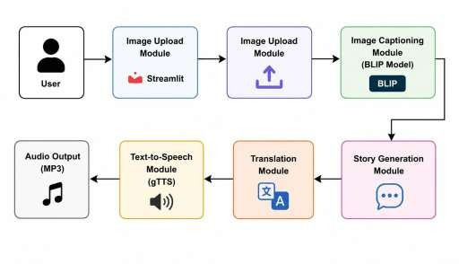

Fig:2 Architecture

UML DIAGRAMS

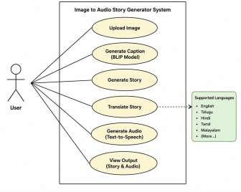

Fig:use case diagram

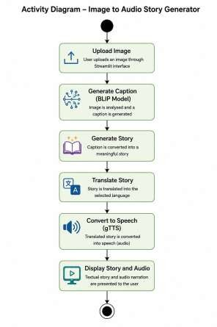
Fig: class diagram
2.2 Algorithm:
- BLIP Image Captioning Algorithm : BLIP (Bootstrapping Language-Image Pre-training) analyzes the uploaded image and identifies objects, scenes, and activities.It generates an accurate textual caption that describes the visual content of the image.
- Vision Transformer (ViT) :Vision Transformer divides the image into smaller patches and extracts important visual features.These features help the system understand the image content more effectively for caption generation.[15]
- Transformer Decoder :The Transformer Decoder converts extracted image features into meaningful natural language text.It generates a coherent caption by predicting words sequentially based on image understanding.[4]
- Natural Language Generation (NLG) :NLG transforms the generated image caption into a complete and readable story.It adds context, creativity, and narrative flow to make the output more engaging.
2.3 Techniques:
- Computer Vision Technique :Used to analyze and understand the visual content of uploaded images. Implemented through the BLIP Image Captioning Model to identify objects, scenes, and activities.[7]
- Image Captioning Technique : Converts image content into descriptive text automatically.Generates captions that serve as the foundation for story creation.
- Transformer-Based Learning :Uses Transformer architecture for image understanding and text generation.
- Natural Language Processing (NLP) :Helps in creating meaningful and grammatically correct stories.

2.4 Tools:
- Python : Python is the primary programming language used to develop and integrate all modules of the Image-toAudio Story Generator.
- Streamlit :Streamlit is used to create an interactive and user-friendly web interface for image upload and output display.[16]
- Visual Studio Code (VS Code) :Visual Studio Code is used as the development environment for writing, testing, and debugging the project code.
- Hugging Face Transformers :The Transformers library provides the BLIP model for generating descriptive captions from uploaded images.
- PyTorch :PyTorch is the deep learning framework used to load and execute the BLIP image captioning model.
2.5 Methods:
The proposed AI-Powered Multilingual Image-to-Audio Story Generation System uses several methods to convert images into audio stories automatically. The Image Upload Method accepts images from users through the Streamlit interface, while the Image Preprocessing Method prepares the images for analysis. The Image Captioning Method uses the BLIP model to generate descriptive captions by understanding image content. [17]The Feature Extraction Method identifies important visual elements such as objects and scenes. The Story Generation Method transforms captions into meaningful narratives, and the Language Translation Method converts stories into the user's preferred language. The Text-to-Speech Conversion Method generates audio narration from the translated text, while the Audio File Generation and Playback Methods create and play the MP3 audio output. Additionally, the User Interaction Method, File Handling Method, and Multilingual Processing Method ensure smooth operation, efficient file management, and support for multiple languages, providing a complete end-to-end multimedia storytelling solution.[18]

III. METHODOLOGY
3.1 Input:
The input to the AI-Powered Multilingual Image-to-Audio Story Generation System consists of an image uploaded by the user through the Streamlit-based web interface. The system accepts image files in common formats such as JPG, JPEG, and PNG. [8]Along with the image, the user can select a preferred output language such as English, Telugu, Hindi, Tamil, or Malayalam. The uploaded image serves as the primary source of information for the system, which is then analyzed using the BLIP image captioning model to identify objects, scenes, and activities. These inputs are processed further to generate a story, translate it into the selected language, and convert it into audio narration. Input Details
- Input 1: Image File (JPG, JPEG, PNG)
- Input 2: Language Selection (English, Telugu, Hindi, Tamil, Malayalam)
- Input Source: User Upload via Streamlit Interface
- Input Purpose: Generate Caption, Story, Translation, and Audio Narration from the Image.

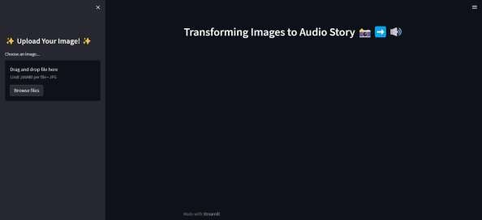
Fig: Giving Input
  - Method of Process:
The Image-to-Audio Story Generation System follows a systematic process to convert an uploaded image into a multilingual audio story. First, the user uploads an image through the Streamlit web interface. The image is then preprocessed and analyzed using the BLIP Image Captioning Model, which generates a descriptive caption based on the visual content. [9]Next, the caption is transformed into a meaningful story using Natural Language Generation (NLG) techniques. The generated story is translated into the user-selected language through Neural Machine Translation (NMT). After translation, the story is converted into speech using Google Text-to-Speech (gTTS) technology. Finally, the system generates an MP3 audio file and displays both the textual story and audio narration to the user through the interface.
  - Output:
The system generates a descriptive caption from the uploaded image using the BLIP model and converts it into a meaningful story. The story is translated into the selected language and then transformed into speech using gTTS. Finally, the system produces an MP3 audio file and displays both the textual story and audio narration through the Streamlit interface. This provides a complete multimedia storytelling experience for the user.
.

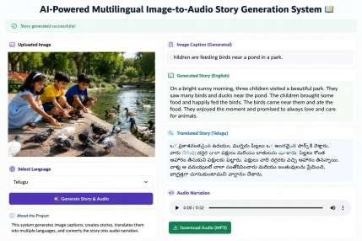
Fig:Output Screen
- RESULTS:
The system successfully converts uploaded images into meaningful stories and audio narrations. It generates accurate image captions using the BLIP model, translates stories into multiple languages, and produces MP3 audio using gTTS. The application effectively integrates image captioning, story generation, translation, and speech synthesis into a single platform. The results demonstrate an efficient, user-friendly, and accessible multimedia storytelling solution.
- DISCUSSION:
The project successfully converts images into multilingual audio stories by integrating image captioning, story generation, translation, and speech synthesis. The system provides accurate and user-friendly outputs, improving accessibility and creating an engaging multimedia storytelling experience
- CONCLUSION
The AI-Powered Multilingual Image-to-Audio Story Generation System successfully converts images into meaningful stories and audio narrations using Artificial Intelligence techniques. The system integrates image captioning, story generation, language translation, and text-to-speech synthesis into a single platform. It provides an accessible and userfriendly solution for transforming visual content into multilingual audio information. The project demonstrates the effective application of Computer Vision, Natural Language Processing, and Speech Technologies in multimedia storytelling and accessibility enhancement.
- FUTURE SCOPE:
The system can be enhanced by integrating advanced Large Language Models (LLMs) to generate more creative and context-aware stories. Future versions may support real-time image processing, mobile applications, and offline functionality. Additional features such as emotion-aware storytelling, customizable voice narration, and support for more languages can improve user experience. The system can also be integrated with educational platforms and assistive technologies for visually impaired users.
.

- ACKNOWLEDGEMENT:


Satish Varada working as an Assistant Professor in Masters of Computer Applications (MCA) in SVPEC, Visakhapatnam, Andhra Pradesh. Completed his Post graduation in PB Siddartha College of arts and Science,Krishna University. With accredited by NAAC with her areas of interest in java, Database management system.


Vakada Mahendra Reddy is pursuing his final semester MCA in Sanketika Vidya Parishad Engineering College, accredited with A grade by NAAC, affiliated by
Andhra University and approved by AICTE. With interest in Artificial Intelligence
Vakada Mahendra Reddy has taken up his PG project on IMAGES TO AUDIO
STORY GENERATOR BY USING PYTHON and
published the paper in connection to the project under the guidance of V. SATISH, Assistant Professor, SVPEC.
.

REFERENCES

- Image Generation Using AI with Effective Audio Playback System https://ieeexplore.ieee.org/abstract/document/10593387

- Artificial Intelligence in Multimedia Content Generation: A Review of Audio and Video Synthesis Techniques https://sid.onlinelibrary.wiley.com/doi/full/10.1002/jsid.2111

- Leveraging AI to Generate Audio for User-generated Content in Video Games https://arxiv.org/abs/2404.17018
- AIM: ARTIFICIAL INTELLIGENCE FOR MULTIMEDIA GENERATION
https://library.iated.org/view/CHRIST2024AIM

- Design implications of generative AI systems for visual storytelling for young learners https://dl.acm.org/doi/abs/10.1145/3585088.3593867

- The Future of Content Creation: Leveraging AI for Code, Text, Music, and Video Generation https://ieeexplore.ieee.org/abstract/document/10775258
- AI-Driven Multi-modal Story Generator by Integrating Image Understanding with Creative Narrative Generation Using Gemini and OpenAI APIs https://link.springer.com/chapter/10.1007/978-3-031-98360-3_12

- AI-Driven Contextual Story Creation with Integrated Text and Visual Generation https://ieeexplore.ieee.org/abstract/document/10757014

- Revolutionizing Visuals: The Role of Generative AI in Modern Image Generation https://dl.acm.org/doi/full/10.1145/3689641

- AI-driven audio-to-video generation for dynamic content creation via stable diffusion and CNN-augmented transformers https://www.nature.com/articles/s41598-026-38758-3

- Audio Book Creation System Using Artificial Intelligence https://ieeexplore.ieee.org/abstract/document/10982688

- AI-Empowered Persuasive Video Generation: A Survey https://dl.acm.org/doi/full/10.1145/3588764

- AI in the media and creative industries https://arxiv.org/abs/1905.04175

- A Study on the Use of AI Image Generation Tools for Picture Book Illustration Development https://accesson.kr/ijcon/v.21/3/60/57462

- A Generative-Artificial-Intelligence-Powered Platform for an Educational Story-teller https://ieeexplore.ieee.org/abstract/document/11166230

- AudioGen: Textually Guided Audio Generation https://arxiv.org/abs/2209.15352

- AI-Generated Content (AIGC) for Various Data Modalities: A Survey https://dl.acm.org/doi/full/10.1145/3728633

- An Exploratory Study on Multi-modal Generative AI in AR Storytelling https://arxiv.org/abs/2505.15973

- Narratology meets text-to-image: a survey of consistency in AI generated storybook illustrations https://link.springer.com/article/10.1007/s10462-025-11482-6
- Artificial intelligence in the creative industries: a review https://link.springer.com/article/10.1007/s10462-021-10039-7

- Artificial Intelligence & Large Language Models : Cooperative AI story writing https://www.theseus.fi/handle/10024/860183

- A Study of NLP and AI-Driven Online Text-to-Video Generation Platforms in Social Media https://ieeexplore.ieee.org/abstract/document/10912131

- Recent advances in artificial intelligence for video production system https://www.tandfonline.com/doi/abs/10.1080/17517575.2023.2246188

